**Week 1 HW 1 Name__________________Hr____**

**Record all work (with clear and logical progressions) and solutions on a separate sheet.**

**Quadratic Basics:**

1. Show that the equation  can be rewritten in the form .
2. Any equation in the form , where *a*, *b*, and *c* are constants, is said to be written in general form. Rewrite  in general form.
3. Rewrite  in the form .
4. Using mental math only, verify that  can also be written as .
5. Any equation in the form  is said to be written in factored form. Write  in factored form.

Hint:

1)  if and only if  and 

2)  for *x*-values where and 

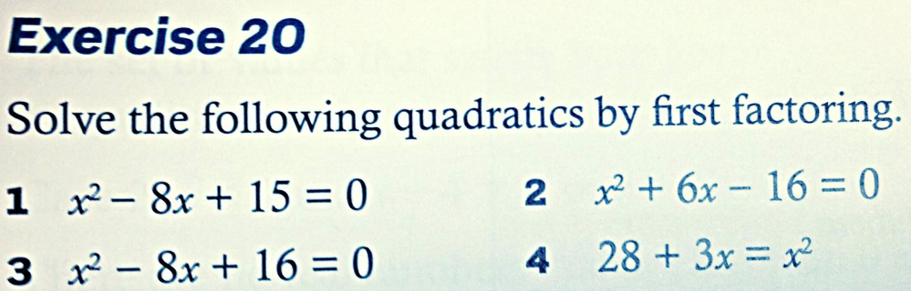

**9.**

**8.**

**7.**

**6.**

**Quadratic Formula:**  If  then $.$

1. Use the Quadratic Formula to find the roots (when $y=0$) of the equation below. Then show you have the correct solution(s) by plugging them back in for x.



1. Use the Quadratic Formula to find the roots of the equation below. Then show you have the correct solution(s) by plugging them back in for x.



Use the quadratic formula OR factoring to find the roots (*x*-intercepts where $y=0$) of each graph below. Your answers should agree with the graph shown. Label the values of the roots on the x-axis on each graph.

**12.**

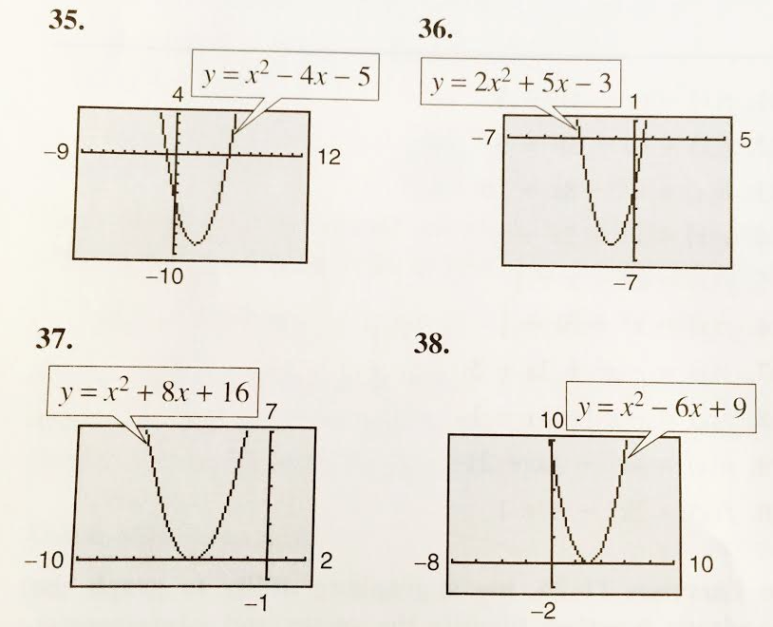

**15.**

**14.**

**13.**

1. **Simplify: $\frac{16{\left(x^{3}y\right)}^{6}}{2xy^{10}}$**
2. **Expand: $3x^{2}\left(x^{3}+2x+1\right)$**
3. **Expand: $\left(3^{x}+2\right)\left(3^{x}-5\right)$**
4. **Expand:** 
5. **Simplify to one fraction: $\frac{3x}{4}+\frac{x+2}{6}$**

**Solve the following for x. Check your answer(s) in the original equation.**

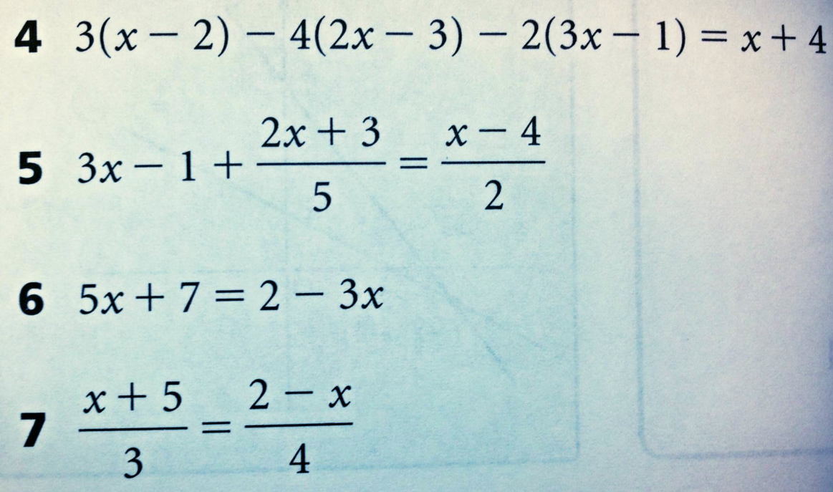

**24.**

**23.**

**22.**

**21.**

**HW 1.2**

1. Point slope form. .
2. Find the equation of a line with slope of 3 passing through the point (2, 4).
3. Find the equation of a line with slope of -2 passing through the point (1, 10).
4. Find the y-intercept of a line with slope of -5 passing through the point (10, 40).
5. Find the equation of the line passing through (3, 10) and (6, 16).
6. 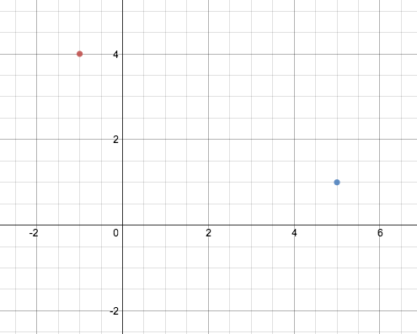Slope: Identify the slope of each line.

a. 

b. 

c. 

d. 

e. The line that passes through the points shown at right.

1. Perpendicular lines have slopes that are negative reciprocals of one another.
2. Line *l* has slope 4. What is the slope of the line that is perpendicular to *l*?
3. Line *t* has slope 8. What is the slope of the line that is perpendicular to *t*?
4. Line *q* has slope . What is the slope of the line that is perpendicular to *q*?
5. Line *r* has slope . What is the equation of the line that is perpendicular to *r* and passes through the point (8, 12)?
6. Line *w* has slope . What is the equation of the line that is perpendicular to *w* and passes through the point (6, 1)?
7. The shortest distance between a line and a point is the perpendicular distance from the line to the point.
8. Line *l* has the equation . Line *p* is perpendicular to *l* and passes through the point (4, 8). Find the intersection of the two lines. What is the significance of this point?
9. Line *v* has the equation . Line *m* is perpendicular to *v* and passes through the point (-2, 12). Find the intersection of the two lines. What is the significance of this point?
10. Line *z* has the equation . Line *b* is perpendicular to *z* and passes through the point (10, 100). Find the intersection of the two lines. What is the significance of this point?
11. Solve each equation for *y*.

a. 

b. 

c. 

1. Use the SUBSTITUTION method to solve for *x* and *y*. Note: Your answers from problem 29 will be helpful.

a. 

b. 

c. 

*y*

*x*

1. **Solve the system by graphing, substitution, and elimination.**

$2x-4y=20$

$3x+2y=6$

**Explain what it means to solve a system of equations.**

1. A security officer is chasing a shoplifter at the mall. Sally is viewing the chase from the kiosk that she works at. Their positions can be represented on an (*x*, *y*) coordinate axis. The security officer begins at the point (-2, -3); he moves in a straight line such that he travels 3 meters north and 4 meter east every second. Sally is working at a kiosk located at the point .

|  |  |
| --- | --- |
|  | 1. Plot Sally’s position and the path of the officer on the graph to the left. 2. The shortest distance from Sally to the officer’s path is the perpendicular distance from the point representing her location to the line representing his path. Write an equation of the line passing through Sally’s kiosk, perpendicular to the security officer’s line. 3. Find the intersection of the two lines. 4. How close does the officer come to Sally’s kiosk?      1. At what time did this occur? |