Name_______________
Date__________________

Advanced Algebra
Unit 2 – Quiz #1 Common Quiz Form A
- Use the functions $f\left(x\right)=-2x+4$ and $g\left(x\right)=\frac{x+3}{x-5}$ to find each value
- $f(3)$______________________

- $f\left(7\right)+f(0)$__________________

- Find x when $f\left(x\right)=0$_________________

- Given h(3) = 2, what is the ordered pair on the graph? __________________________

- $f(g\left(1\right))$________________

- $g(f\left(-1\right))$_________________

- $f(g\left(x\right))$____________________

- $f(x+1)$_____________________

- Tell whether each relation is a function:
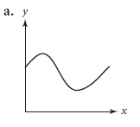
Write your answer here:
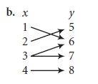
Write your answer here:

