**FOUNDATIONAL: 6 points each.**

**ONE:**

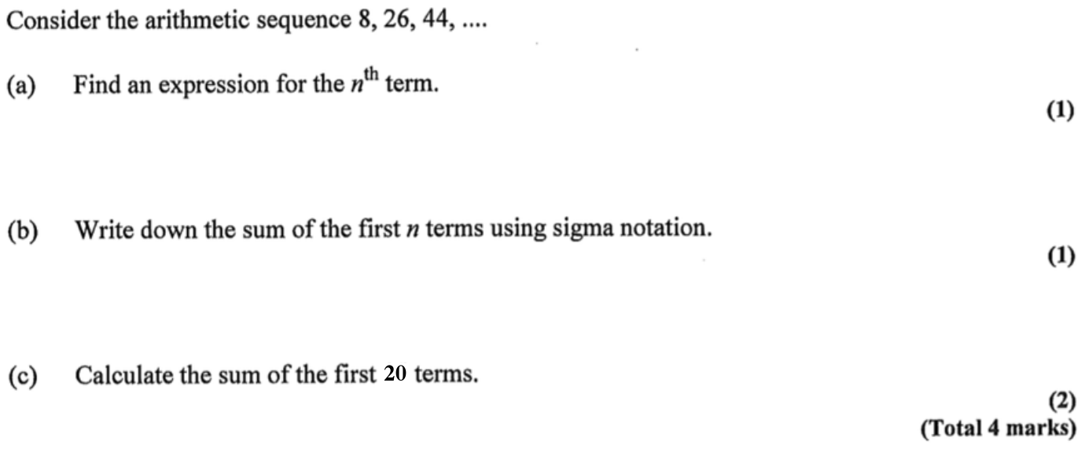

**TWO:** An arithmetic sequence, , has first term of 2 and a common difference of 12. Find:

a. An expression for the nth term. [2 marks]

b. . [2 marks]

c. The value of the smallest term that is greater than 470. [2 marks]

**MODERATE: 4 points each.**

**THREE:**

35



**FOUR:**

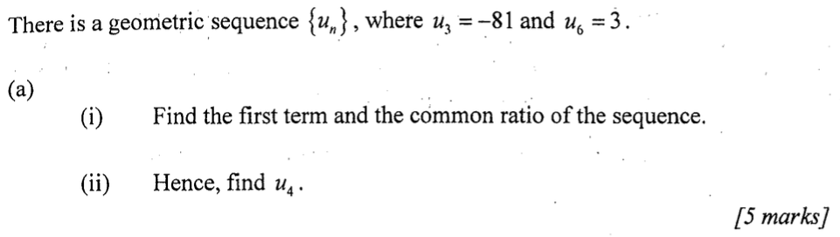

**HIGH CHALLENGE: 2 points each.**

**FIVE:** [6 marks]

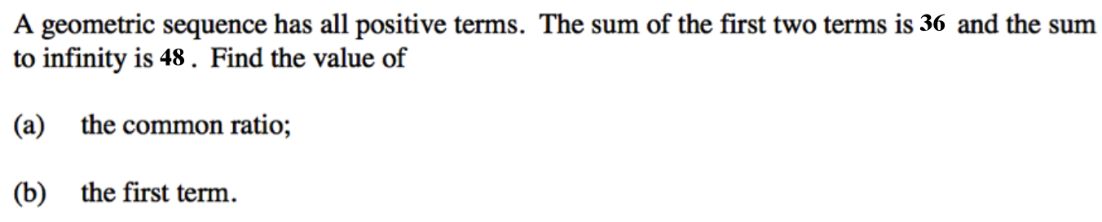

**SIX:**  [6 marks]

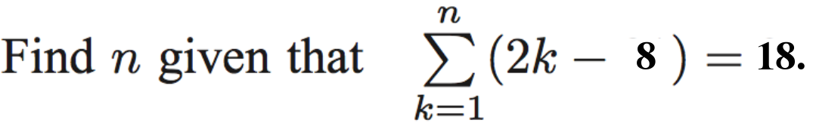

<https://goo.gl/wi3p3c> 