Foundational:

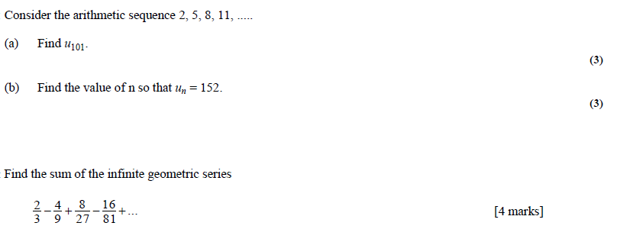

- (might actually be a calculator use question)
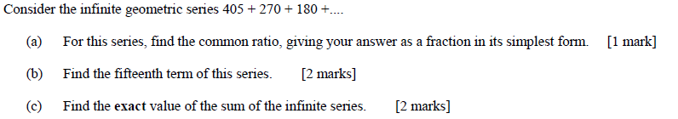

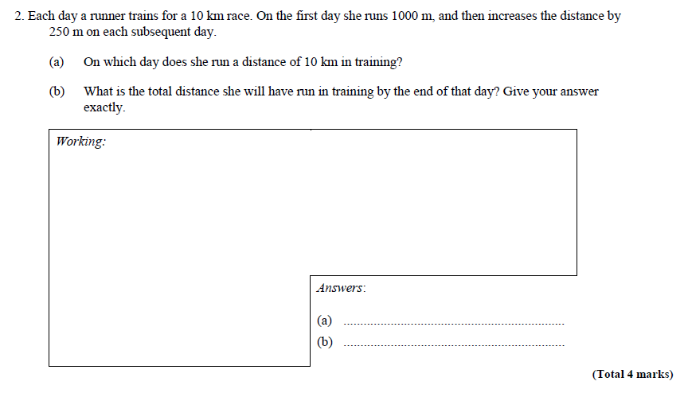

Moderate: (4 marks each)

- Find the sum of the first 5 terms of Vn if the 3rd term is 15 and the 7th term is 1215, and Vn is….

  - Arithmetic (4 marks)

  - Geometric (4 marks)

High Challenge:

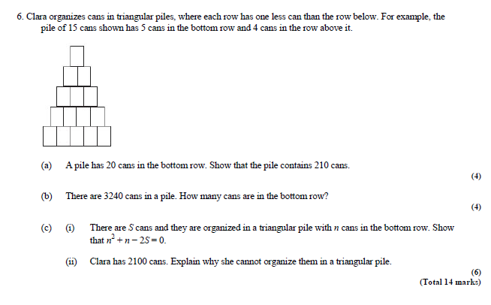

https://goo.gl/BhXUzP

