SL 1 Probability Review #3 Name______________________________Hr:__

ONE: NON CALCULATOR FOUNDATIONAL
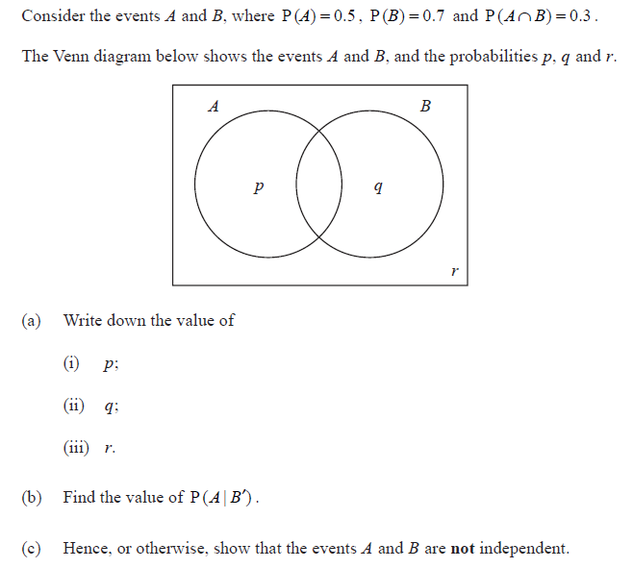
Circle the elements that this problem contains:
Tree diagram
Venn diagram
Pascal’s Triangle
Independent events
Dependent events (conditional probability)

TWO: NON CALCULATOR FOUNDATIONAL
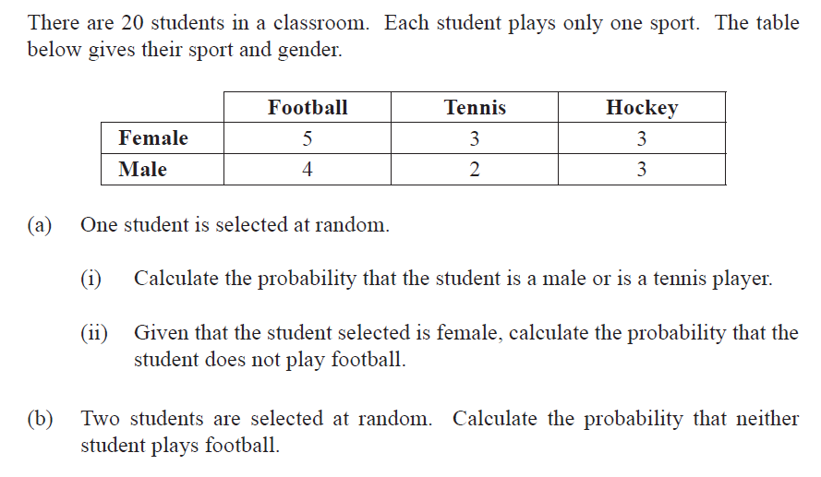
Circle the elements that this problem contains:
Tree diagram
Venn diagram
Pascal’s Triangle
Independent events
Dependent events (conditional probability)

THREE: NON CALCULATOR FOUNDATIONAL
Circle the elements that this problem contains:
Tree diagram
Venn diagram
Pascal’s Triangle
Independent events
Dependent events (conditional probability)

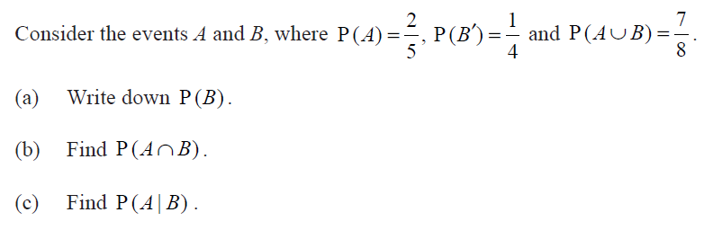

FOUR: WITH CALCULATOR FOUNDATIONAL
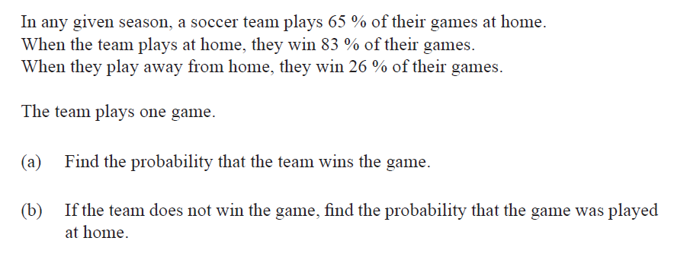
Circle the elements that this problem contains:
Tree diagram
Venn diagram
Pascal’s Triangle
Independent events
Dependent events (conditional probability)

FIVE: WITH CALCULATOR FOUNDATIONAL

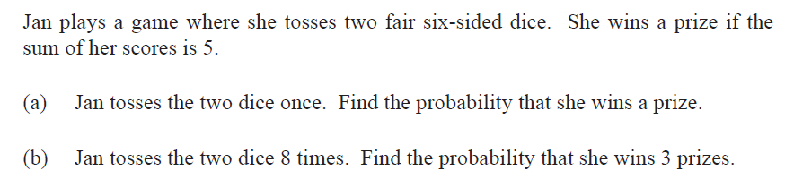
Circle the elements that this problem contains:
Tree diagram
Venn diagram
Pascal’s Triangle
Independent events
Dependent events (conditional probability)

Six: WITH CALCULATOR MODERATE
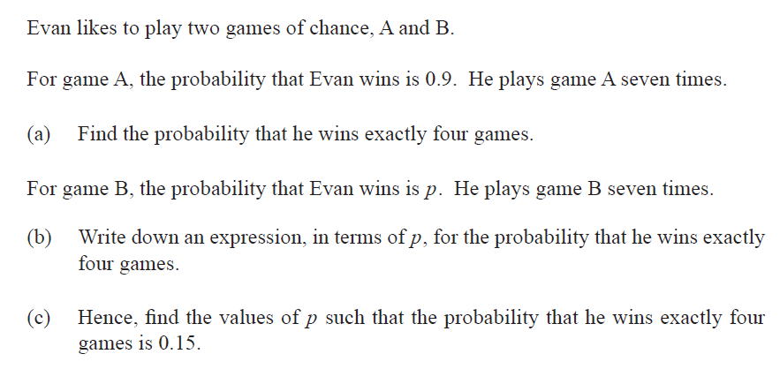
Circle the elements that this problem contains:
Tree diagram
Venn diagram
Pascal’s Triangle
Independent events
Dependent events (conditional probability)

https://goo.gl/6W8sqz

