ONE: NON CALCULATOR FOUNDATIONAL

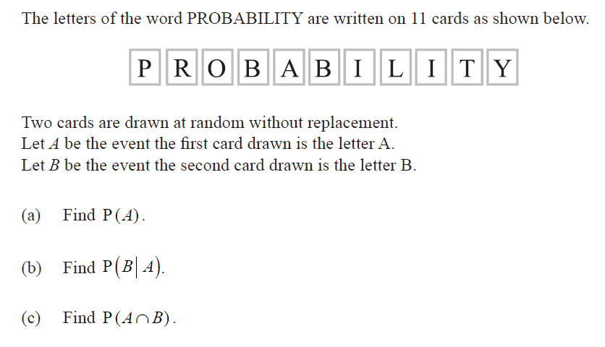
Circle the elements that this problem contains:
Tree diagram
Venn diagram
Pascal’s Triangle
Independent events
Dependent events (conditional probability)

TWO: NON CALCULATOR FOUNDATIONAL
Circle the elements that this problem contains:
Tree diagram
Venn diagram
Pascal’s Triangle
Independent events
Dependent events (conditional probability)

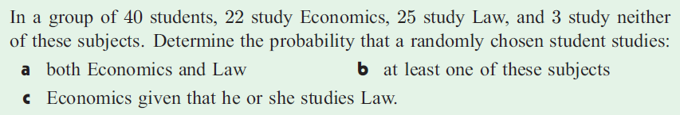

THREE: NON CALCULATOR MODERATE
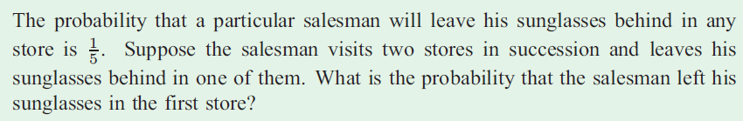
Circle the elements that this problem contains:
Tree diagram
Venn diagram
Pascal’s Triangle
Independent events
Dependent events (conditional probability)

FOUR: NON CALCULATOR FOUNDATIONAL (a), MODERATE (b)-(c)
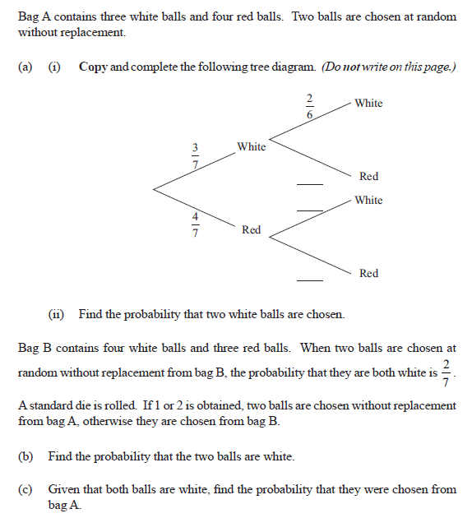
Circle the elements that this problem contains:
Tree diagram
Venn diagram
Pascal’s Triangle
Independent events
Dependent events (conditional probability)

FIVE: WITH CALCULATOR FOUNDATIONAL (a), MODERATE (b)

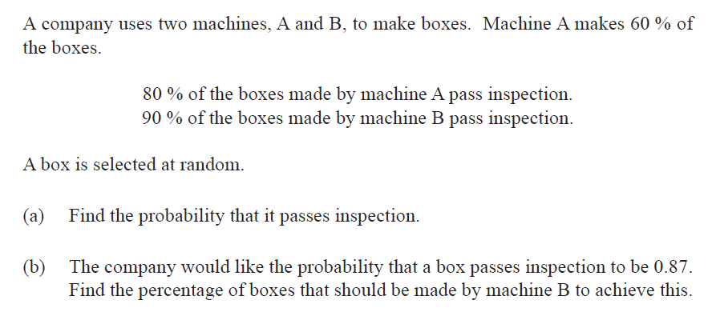
Circle the elements that this problem contains:
Tree diagram
Venn diagram
Pascal’s Triangle
Independent events
Dependent events (conditional probability)

https://goo.gl/lgdj7o 