**SL Year 1: More Review Name____________________Hr_____**

**Logarithms and Exponents**

**Foundational Paper 1: 6 points each (No Calculator)**

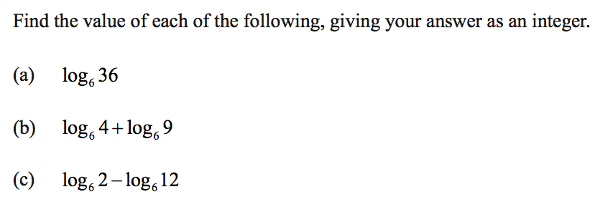

1. Simplify: 
2. Simplify: 

**Moderate Paper 1: 4 points each (No Calculator)**

1. 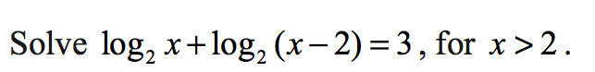

$\log_{2}\left(x+1\right)+\log_{2}{(x-3)}=5$

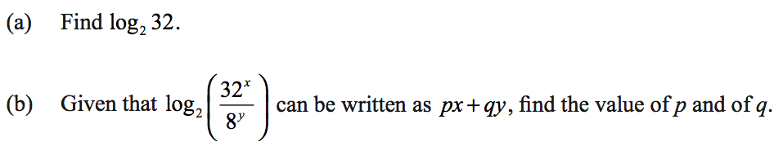

**Foundational Paper 2: 6 points each (With Calculator)**

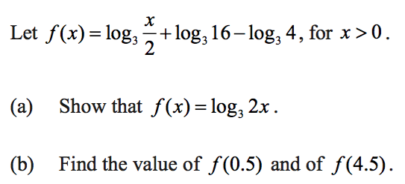

**Moderate: (With Calculator) 4 points each**



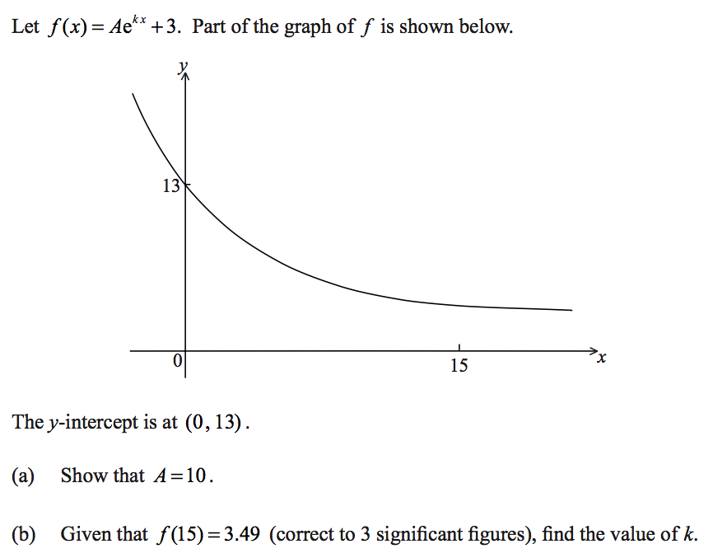

1. Find when $f(x)$ from question number 7 is equal to $g\left(x\right)=e^{x}$ (rounding to nearest thousandth). Explain how you found your answer.

**High Challenge (With Calculator): 2 points each**

A scientist is modeling the number of bees in a beehive. If B is the number of bees in the hive *t* days after the start of the observation period, she uses the following model:

, where *b* is a constant.

1. Find the number of bees at the start of the observation.
2. When t=4, the number of bees was 2214. Show that in this case, the model requires that b=1.50.
3. If b=1.5, find when the number of bees reaches 5000.
4. Expand .
5. Let . Express  in terms of *j*.

Consider the equation .

1. Show that .
2. Hence, solve for *x*.

goo.gl/skCV2t