SL 1: Quadratic Problem Solving Names_______________________Hr____

- A farmer with 2000 ft of fencing wants to enclose a rectangular area and then divide it into five pens with fencing parallel to one side of the rectangle. One side has access to a river and does not need fencing.

- Given the information above and the diagram below, SHOW that the total area of the five pens can be expressed as $A=2000x-6x^{2}$ ft².
- Find the maximum area possible of all five pens together. Show work and/or explain your reasoning.
y

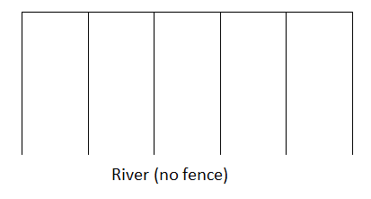

x

- State the values of C when ${y=2x}^{2}+5x+C$ will have . . .

- Only one x-intercept.
- Two different x-intercepts.
- No x-intercepts.

- A movie theater finds that they have been averaging 1200 customers per week when they charge $5 per person. Consequently, the theater’s current weekly income is $1200 people×\$5 per person=\$6000$. To increase their income they are considering changing the price. Through surveying the customers they have determined that for every 50 cent increase to the ticket price, they will lose 50 customers per week (and gain 50 customers for every 50 cent decrease). Find the ticket price that will maximize their weekly income and the weekly income at that price. [HINT: Create an income equation in terms of x, where x represents the number of 50 cent increases. Income = number of customers times price per person.]

- Find the values of k when $y=x^{2}+\left(2k\right)x+\left(k+\frac{3}{4}\right)$ has only one repeated real root.

- A school group paid $180 to book a laser tag facility for 2 hours. At the last minute, six additional students came. This reduced the cost per person by $1.50. How many students went to the laser tag facility?
[HINT: There are two unknowns: (x) the number of students and (y) the cost per person. Create two different equations relating x, y, and $180 – one of the original group and one with the changed group. Then use substitution to create a single equation and solve for x.]

