**SL 1 –Functions NON CALCULATOR Exam Practice Name____________________________**

Foundational:

ONE

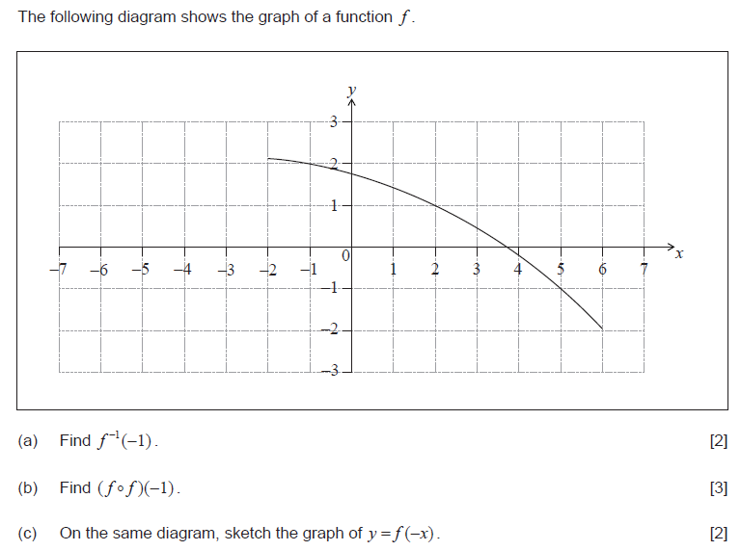

TWO

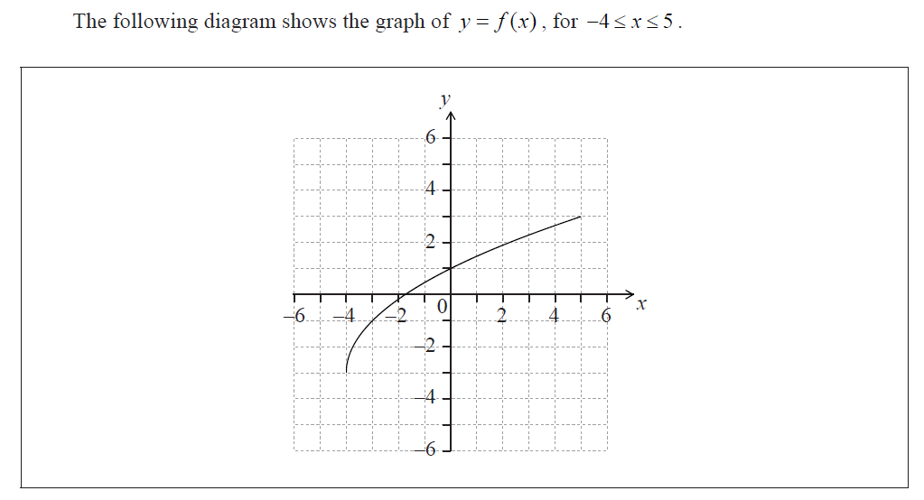

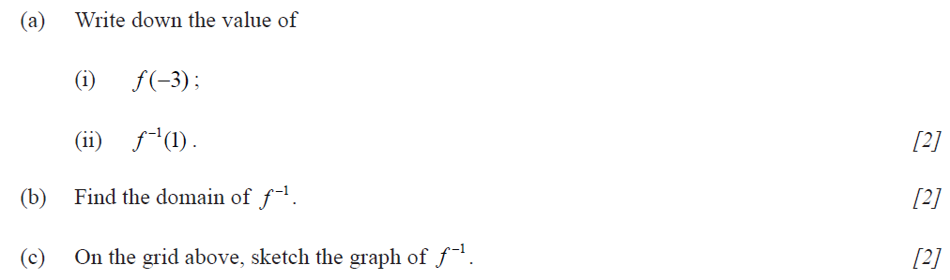

Foundational NON CALCULATOR Continued:

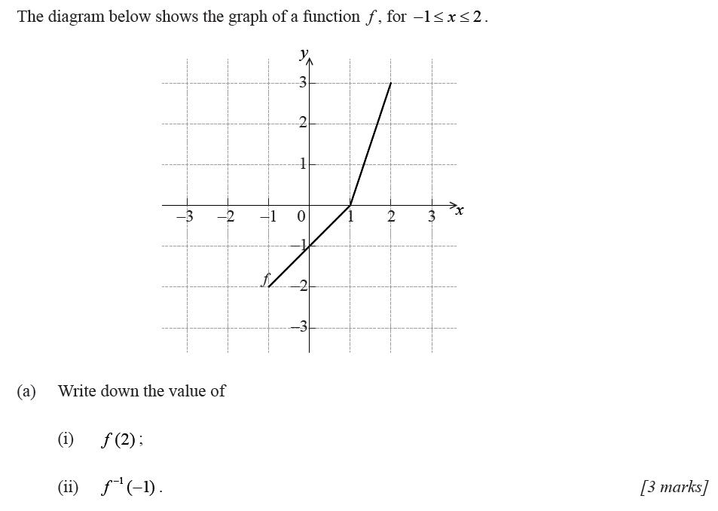

THREE:

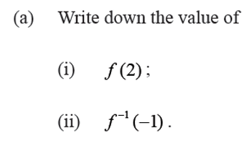

(b) Sketch the graph of $f^{-1}(x)$ on the graph at left.

FOUR:

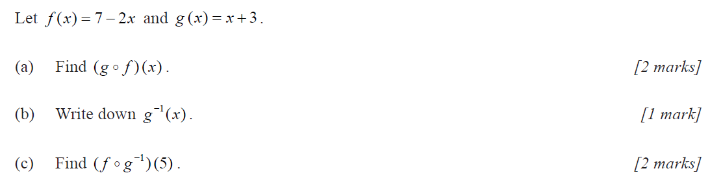

FIVE:

FIVE:

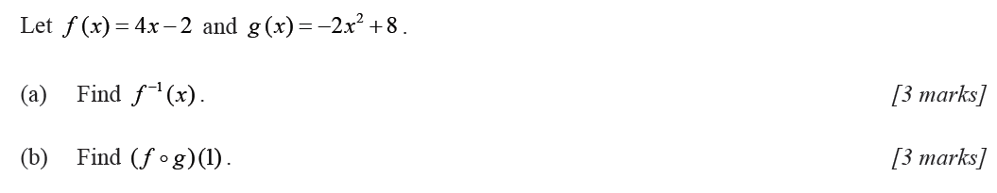

SIX:

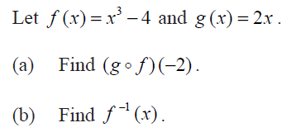

SEVEN:

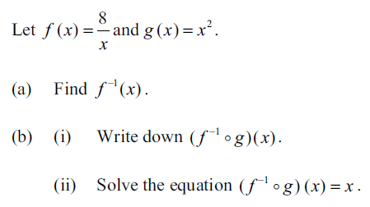

Moderate NON CALCULATOR:

EIGHT:

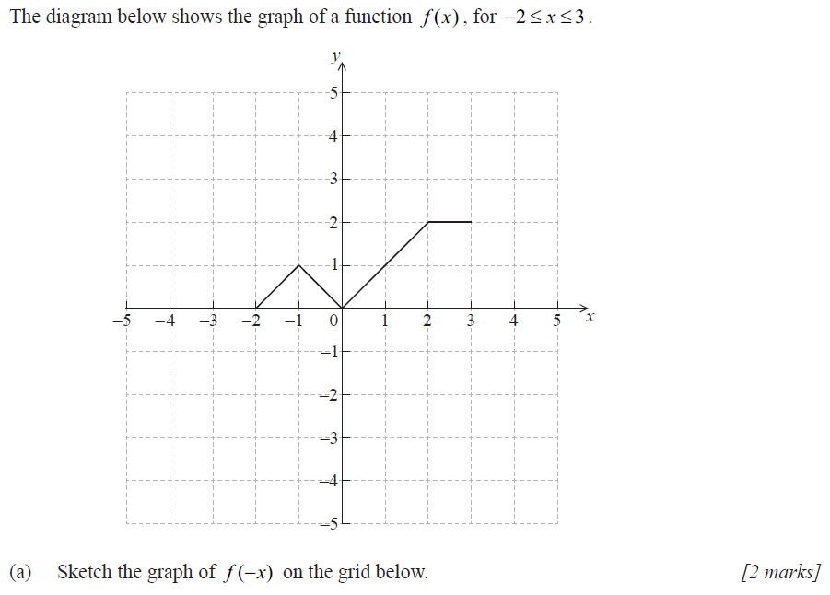

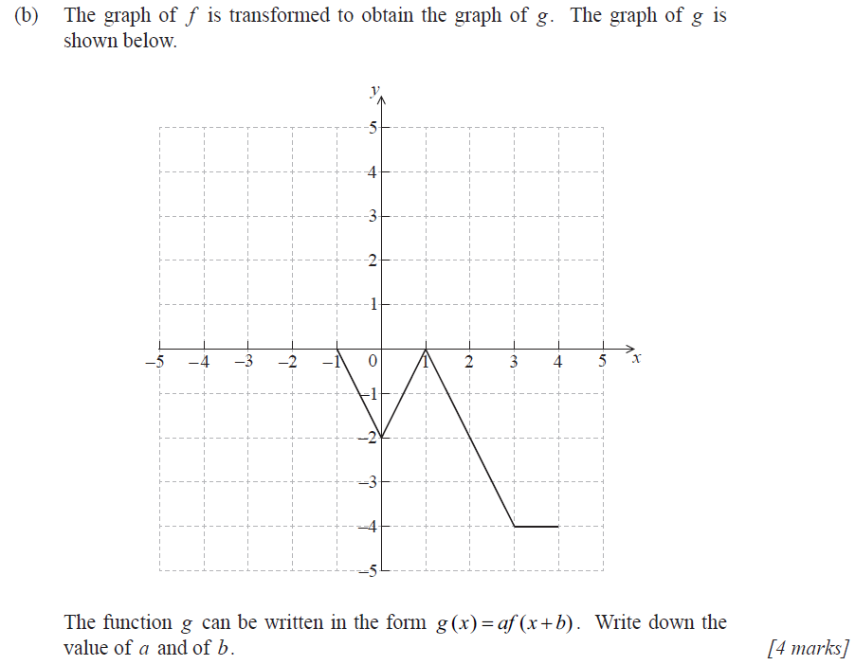

above.

NINE:

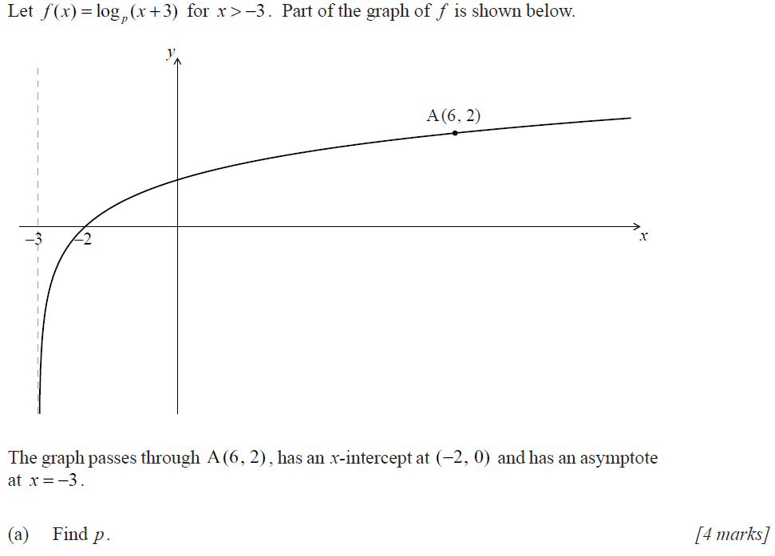

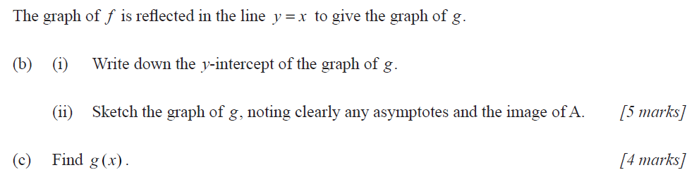

Moderate NON CALCULATOR continued:

TEN:

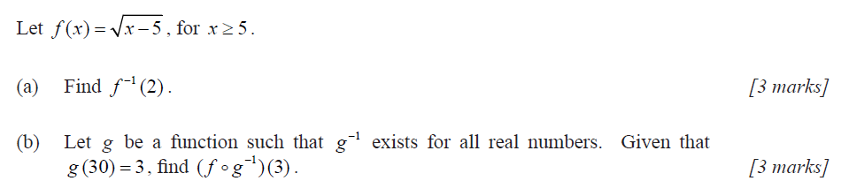

ELEVEN:

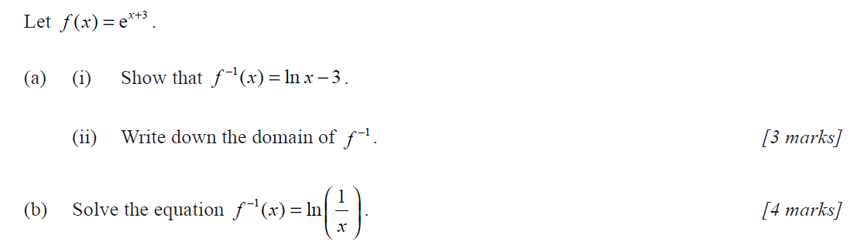

TWELVE:

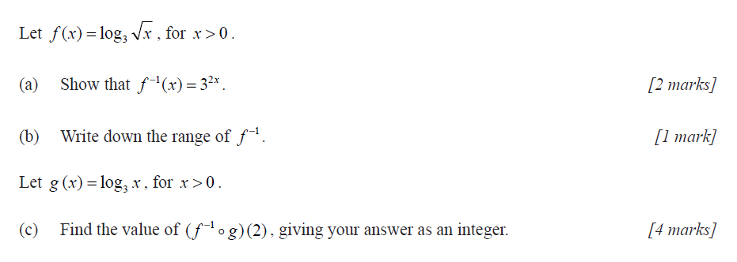

THIRTEEN:

