Advanced Algebra Name_______________________________
Probability Review

Target #1 – I can find the probability of single events.

- There are 11 freshman, 19 sophomores, 7 juniors, and 13 seniors in the marching band. What is the probability that a randomly chosen marching band member is a sophomore? Give the answer as PERCENT, DECIMAL, and REDUCED FRACTION.

A bag of M & M’s contain 3 blue, 6 green, 2 yellow, 5 orange, and 8 brown M & M’s. You choose an M&M at random.

A. $\frac{3}{23}$ B. $\frac{1}{8}$ C. $\frac{1}{3}$ D. $\frac{3}{5}$
- ______ What is the probability that you select a blue M&M?
- ______ What is the probability that you do not select an orange?
A. $79\%$ B. $21\%$ C. $26\%$ D. $65\%$
The spinner at right is from a school carnival. The sad face does not win a prize.

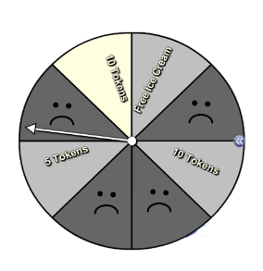
- ______ Find P(10 tokens) -- [The probability of landing on a “10 tokens” sector]
A. $50\%$ B. $20\%$ C. $25\%$ D. $12.5\%$
- ______ Find P(not getting free ice cream)?
A. $\frac{1}{8}$ B. $\frac{3}{8}$ C. $\frac{3}{4}$ D. $\frac{7}{8}$
- ______ Find the probability of not winning a prize.
A. $50\%$ B. $20\%$ C. $25\%$ D. $12.5\%$

Target #2 – I can find the probability of “AND” and “OR” single events.

- What has a greater chance of occurring, choosing a random student from Washburn that . . .

  - . . . plays a varsity sport AND is a 10th grader
  - . . . plays a varsity sport OR is a 10th grader

Explain:

Target #2 continued
- Charlie is playing a card game where he wins if he draws a purple card or a card with a 1 on it. There are 7 total cards: three purple cards with the numbered 1-3 and four green cards with the numbered 1-4. He says that the probability of winning is $\frac{5}{7}$ because there are 3 purple cards and 2 cards with a 1 on it.
List out the sample space and explain why Charlie is correct or incorrect.

For #9-11 use the table at right. If the CEO is selected at random, find the probability that his or her age is . . .
Age | Frequency
21-30 | 1
31-40 | 8
41-50 | 27
51-60 | 29
61-70 | 24
71+ | 11
Total | 100
The distribution of ages of CEOs
- ______ P(over 60)
A. $\frac{6}{25}$ B. $\frac{2}{35}$ C. $\frac{7}{20}$ D. $\frac{13}{20}$
- ______ P(over 30 and under 51)
A. $100\%$ B. $35\%$ C. $3\%$ D. $21\%$
- ______ P(under 31 or over 70)
A. $12\%$ B. $88\%$ C. $0\%$ D. $70\%$

A blood bank catalogs the types of blood, including positive or negative Rh-factor, given by donors during the last five days. There were a total of 400 donors. The number of donors who gave each blood type is shown in the table.
 | O: 181 | A: 162 | B: 43 | AB: 14  Total Donors: 400
Rh-Positive: 339 | 154 | 138 | 36 | 11
Rh-Negative: 61 | 27 | 24 | 7 | 3

If a single donor is chosen at random from the 400, find the probability that the donor has the given characteristics.
A. $73\%$ B. $86\%$ C. $90\%$ D. $84\%$
- ______ P(type O or type A blood)
A. $9\%$ B. $46\%$ C. $55\%$ D. $60\%$
- ______ P(A blood, B blood, or AB blood)
A. $9\%$ B. $20\%$ C. $87\%$ D. $96\%$
- ______ P(B blood and is Rh-Positive)
- ______ P(B blood or is Rh-Positive)
A. $64\%$ B. $57\%$ C. $49\%$ D. $41\%$
A. $9\%$ B. $20\%$ C. $87\%$ D. $96\%$

- ______ P(O blood, AB blood, or is Rh-Negative)
Target #3 – I can use area formulas to find geometric probability.

- Describe the process you would use to find the probability that a randomly chosen point in the hexagon at right lies in the shaded region.

Find the probability that a randomly chosen point lies in the shaded region.
6
8
5
3
10
28

- ______

A. $\frac{5}{16}$ B. $\frac{5}{6}$ C. $\frac{11}{16}$ D. $\frac{3}{8}$

- ______
7
6

A. $55\%$ B. $67\%$ C. $33\%$ D. $86\%$
A. $\frac{9}{10}$ B. $\frac{1}{15}$ C. $\frac{5}{12}$ D. $\frac{4}{5}$

- ______

A. $\frac{5}{14}$ B. $\frac{1}{2}$ C. $\frac{1}{4}$ D. $\frac{2}{5}$

2
2
2
5
12
- ______

Target #4 – I can determine the number of possibilities of an event using the appropriate method of counting
principal, permutations, or combinations.

- Describe the differences between permutations and combinations.

Multiple Choice. Determine the equivalent expression. THERE COULD BE MORE THAN ONE CORRECT ANSWER.

- ___________ $\frac{6!}{4!}$
A) $6∙5$ C) $6∙5∙4$
B) $6∙5∙4∙3$ D) $6∙4$

- ___________ $\frac{7!}{3!∙4!}$
A) $\frac{7∙6}{3∙4}$ C) $\frac{7∙6∙5}{3∙2∙1}$
B) $\frac{7∙6∙5∙4}{4∙3∙2∙1}$ D) $\frac{3∙2∙1∙4∙3∙2∙1}{7∙6∙5∙4∙3∙2∙1}$

- ___________
A) $\frac{3!4!}{7!}$ C) $\frac{7!}{4!}$
B) $\frac{7!}{3!4!}$ D) $\frac{7!}{3!}$
A) $\frac{5!}{2!3!}$ C) $\frac{5!}{2!}$
B) $\frac{2!3!}{5!}$ D) $\frac{5!}{3!}$

- _{___________ 5}P₂
A) $\frac{5!}{2!3!}$ C) $\frac{5!}{2!}$
B) $\frac{2!3!}{5!}$ D) $\frac{5!}{3!}$

Target #4 continued

Determine the correct calculation.

- ______ How many arrangements of the letters in GRAVEL are there?
A. $21$ B. $360$ C. $720$ D. $180$

- ______ There are 12 runners running a mile. How many different ways can the runners finish 1st, 2nd, and 3rd?
A. $180$ B. $1320$ C. $220$ D. $79,833,600$

- ______ A pizza shop has 10 different toppings for their pizzas. How many different 4-topping pizzas can be made?
A. $40$ B. $5040$ C. $210$ D. $151200$

- ______ How many arrangements of the letters in LETTER are there?
A. $21$ B. $360$ C. $720$ D. $180$

- ______ At a restaurant you have to choose a drink (coke, water, or milk), entrée (steak or chicken), and side dish (potatoes, corn, salad, or soup). How many possible meals are there?
A. $24$ B. $288$ C. $720$ D. $180$

- ______ Student council needs 5 representatives from the senior class which contains 300 students. In how many ways can students be chosen to represent the class?
A. $\frac{300!}{5!}$ B. ₃₀₀ P ₅ C. ₃₀₀ C ₅ D. ${300}^{5}$

- ______ A computer password must have 4 letters and then 3 numbers. If repeats are allowed, how many possible passwords are there?
A. ₄ P ₃ B. ${26}^{4}∙{10}^{3}$ C. ₂₆ P ₄$∙$₁₀ P ₃ D. ₂₆ C ₁₀

- ______ A computer password must have 4 letters and then 3 numbers. If repeats are NOT allowed, how many possible passwords are there?
A. ₄ P ₃ B. ${26}^{4}∙{10}^{3}$ C. ₂₆ P ₄$∙$₁₀ P ₃ D. ₂₆ C ₁₀

Target #5 – I can find the probability of multiple events occurring.

- How do you calculate the probability of the same event occurring four times in a row? Give an example.

- ______ What is the probability of rolling 4 on a dice twice in a row?
A. $\frac{1}{3}$ B. $\frac{1}{6}$ C. $\frac{1}{4}$ D. $\frac{1}{36}$

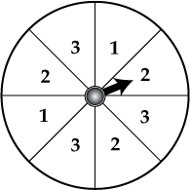
- ______ What is the probability of spinning a 3 with the spinner three times in a row?
A. $\frac{27}{512}$ B. $\frac{3}{8}$ C. $\frac{1}{8}$ D. $\frac{1}{512}$

Use the diagram at right for #38-43.

- ______ Find P(striped then black) if the marble is replaced after the first draw.
A. $\frac{7}{20}$ B. $\frac{1}{10}$ C. $\frac{7}{10}$ D. $\frac{1}{9}$

- ______ Find P(striped then black) if the marble is not replaced after the first draw.
A. $\frac{1}{9}$ B. $\frac{7}{19}$ C. $\frac{1}{10}$ D. $\frac{7}{10}$

- ______ Find the probability of reaching into the bucket and grabbing 3 black marbles at once.
(Grabbing 3 marbles at once is the same as WITHOUT REPLACEMENT.)
A. 8.3% B. 12.5% C. 6% D. 50%

- ______ Find the probability of reaching into the bucket and grabbing 4 marbles at once that are NOT striped.
A. 20% B. 33.3% C. 30% D. 41%

- ______ Find the probability of reaching into the bucket, grabbing 4 marbles at once where AT LEAST one of the marbles is white.
A. 16.7% B. 50% C. 76% D. 83.3%

- ______ On your five day vacation there is a 15% chance it could rain each day. What is the probability that it rains EXACTLY any two of the five days of your vacation?

A. 2.3% B. 1.4% C. 13.8% D. 22%

Target #6 – I can use appropriate models to solve probability questions.

- A weather forecaster says that the probability it will rain on Saturday is 20%, and the probability it will rain on Sunday is 40%. Using some type of probability model, determine the probability that it will rain on at least one of the days.
SHOW ALL OF YOUR WORK and write your answer as a percent.

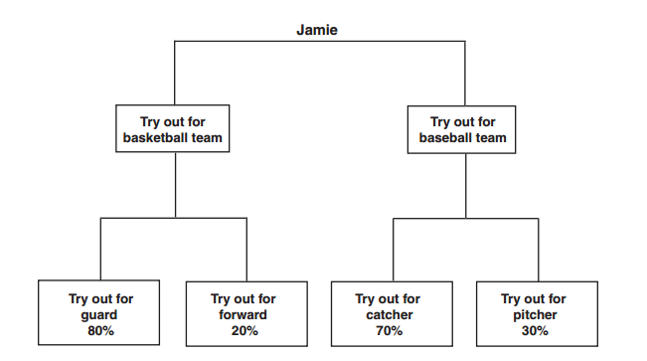
- The probabilities that Jamie will try out for various sports and team positions are shown in the chart below.
Jamie will definitely try out for either basketball or baseball, but not both. The probability that Jamie will try out for baseball and try out for catcher is 42%. What is the probability that Jamie will try out for basketball?
A 40% | B 60% | C 80% | D 90%
SHOW YOUR WORK or EXPLAIN YOUR THOUGHT PROCESS.

- Our city has 2400 subscribers for HipHop magazines Of these, 1200 subscribe to Magazine A, 500 subscribe to Magazine B, and 100 subscribe to both. What is the probability that a subscriber selected at random subscribes to either Magazine A or B? Use a Venn Diagram to find the answer.

