**Law of Sines**

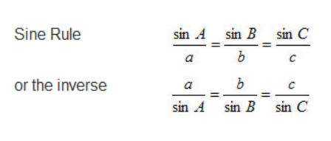

**Draw triangle *RST* and mark it with the given information. Write an equation that could be used to find each unknown value. Then find the value to the nearest tenth.**

1. If 

2. If 

3. If 

**Solve each triangle. Round side measures to the nearest tenth and angle measures to the nearest degree.**

4. 

5. 

6. 

7. 

8. 