Advanced Algebra Name___________________________Hr_______
Intro to Rates of Change, Domain, Range, and Parent Functions
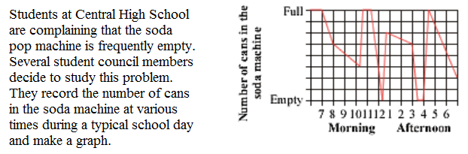
1.
a. When is the soda consumed most rapidly?

b. Domain:

Range:

2. Sketch a graph to match each description:

- increasing throughout, first slowly and then at a faster rate
- decreasing slowly, then more and more rapidly, then suddenly becoming constant
- alternately increasing and decreasing without any sudden changes in rate

3. For each graph, write a description like exercise 2.
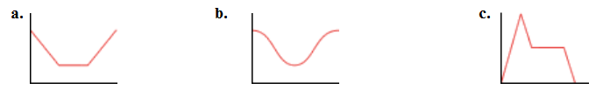

Description: Description: Description:

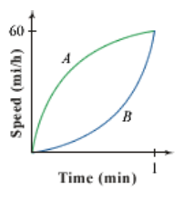
4. Car A and Car B are at the starting line of a race. At the green light, they both accelerate to 60 mi/h in 1 min. The graph at right represents their velocities in relation to time. After 1 minute, which car will be in the lead? Explain your reasoning using the phrase “rate of change.”

Complete each table. Plot the points and create a curve. Describe the curve and state the domain and range.

x | -2 | -1 | 0 | 1 | 2
y

x | 0 | 1 | 4 | 6 | 9
y

Description:

Domain: Range:
Description:

Domain: Range:

5. Linear: $y=x$

x | -2 | -1 | 0 | 1 | 2
y

x | -8 | -1 | 0 | 1 | 8
y

Description:

Domain: Range:
Description:

Domain: Range:
6. Quadratic: $y=x^{2}$

x | -2 | -1 | 0 | 1 | 2
y

x | -2 | -1 | 0 | $$1/2$$ | 1 | 2
y

Description:

Domain: Range:
Description:

Domain: Range:
7. Cubic: $y=x^{3}$

x | -2 | -1 | 0 | 1 | 2
y

8. Absolute Value: $y=\left|x\right|$
Description:

Domain: Range:
9. Square Root: $y=\sqrt{x}$
10. Cubic Root: $y=\sqrt[3]{x}$
11. Reciprocal of Linear: $y=\frac{1}{x}$

x | -2 | -1 | 0 | $$1/2$$ | 1 | 2
y

12. Reciprocal of Quadratic: $y=\frac{1}{x^{2}}$
Description:

Domain: Range:

