Pre-Calculus Concepts
Mathematics tends to build upon earlier mathematics, and calculus is no different.
- General problem solving strategies. This includes using context clues and identifying the givens and the goals of a problem.
- Logic. Strong helps to piece together various approaches to a given problem and helps in using theorems and properties.
- Arithmetic. A large part of the exam does not allow a calculator. You will have to know how to add, subtract, multiply and divide numbers, including fractions and decimals. Therefore, if you have relied on your calculator all throughout high school, now is the time to get back to basics.
- Algebra. This includes simplifying and interpreting algebraic expressions as well as setting up and solving algebraic equations. (Yes, there is a difference — an equation has an equals sign, while an expression does not.) Be familiar with the properties of exponents, logarithms, radicals, etc.
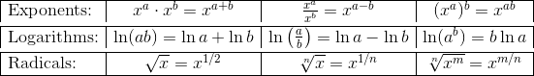
- Geometry. Know your basic perimeter, area, volume, and related formulas. Follow this link for a comprehensive formula sheet.
- Trigonometry. Definitions must be memorized (“SOH CAH TOA“) as well as the most often used trig identities. Memorize the Unit Circle and Pythagorean Identities.
- Pre-Calculus. Know how to graph functions and how to interpret graphs. Be very familiar with linear functions, especially the concept of slope.

Big Idea 1. Limits and Continuity
- Know how to find limits algebraically or by estimating from numerical or graphical data.
- Definition of continuity in terms of limits. Check out Limits and continuity.
- Intermediate Value Theorem (IVT)
If f is continuous on a closed interval [a, b], and if L is any number between f(a) and f(b), then there is at least one value x = c on the interval such that f(c) = L.
- Extreme Value Theorem (EVT)
If f is continuous on a closed interval [a, b], then f attains both an absolute maximum and minimum value on the interval.
- Limits whose values are infinite and their relationship to vertical asymptotes
- Limits as x → ±∞ and their relationship to horizontal asymptotes
- Oblique asymptotes

Big Idea 2. Derivatives and Their Applications
- Limit definition of the derivative
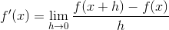
- If a function is differentiable at a point, then it must also be continuous at that point. But not necessarily the reverse — for example, |x| is continuous at x = 0, but not differentiable there.
- Basic derivative rules.
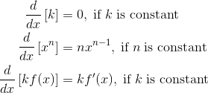
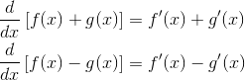
- Derivatives of trigonometric, exponential, and logarithmic functions.
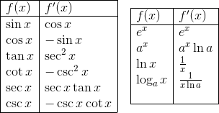
- Product Rule and Quotient Rule
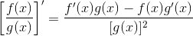
- Chain Rule
- The tangent line to the curve y = f(x) at a point x = a is measured by the derivative: f '(a).
- If s(t) is a position function, then
  - Velocity is v(t) = s '(t), and
  - Acceleration is a(t) = s ''(t).
- Further topics and applications:
  - Implicit Differentiation, Analysis of Graphs, including intervals of increase/decrease, relative minima/maxima, intervals of concavity, and inflection points.
  - Mean Value Theorem and Rolle’s Theorem
  - Optimization
  - Related rates
  - Elementary differential equations and slope fields

Big Idea 3. Integrals and Their Applications
- Rules and formulas of Antidifferentiation
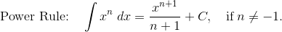
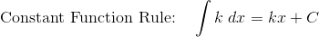
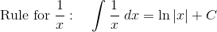
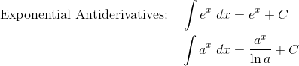
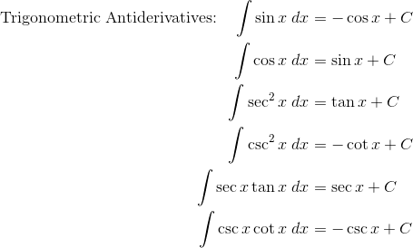
- Integration by Substitution
- The Fundamental Theorem of Calculus (both parts)
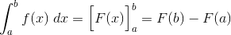
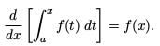
- Area below a curve
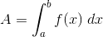
- Area between curves, with f on top and g on bottom
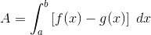
- Volumes of solids of revolution by washer method and shell method.
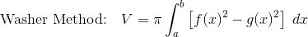
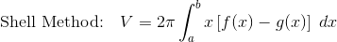
- Further topics and applications:
  - Estimating area or displacement by finite Riemann sums or Trapezoid Rule
  - Average value of a function over an interval
  - Models for exponential growth and decay

