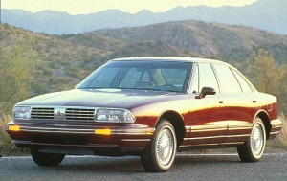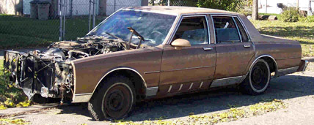
Vehicles tend to lose their value as they get older due to wear and tear, overuse, and weathering.
You buy a new car for $20,000 and it depreciates (loses value) by about 12% per year.

What is the percent change in value each year?

What is that percent as expressed as a decimal?

How much is it worth after one year?

How much is it worth after 3 years?

TABLE OF VALUES
X (years since purchase) | Y(value after x years)
0
1
2
3
4
5
6

TABLE OF VALUES USING ONLY THE NUMBERS $20,000 and 0.88
X (years since purchase) | Y(value after x years)
0
1
2
3
4
5
6
… | …
x

How much will it be worth after 20 years?
Estimate from the table:

Actual calculation:

When will it be worth $5,000
Estimate from the table:

Actual solving:

What is the asymptote of this pattern? (What is an asymptote, by the way????)

