Name: _____________________________
Unit 3 – Exponential and Logarithmic Functions
Activity – Expansion, Factorization, and Solving

1.
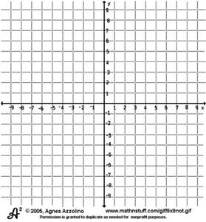
- Graph the following function.

$y=x^{\frac{1}{2}}\left(x^{\frac{3}{2}}+2x^{\frac{1}{2}}+3x^{-\frac{1}{2}}\right)$

- Simplify the function using exponential rules.

- Rewrite the original function using radicand
instead of fractional exponents.

- State the domain and range of the function. Explain why this is.

2. Use the following function to answer the questions below. $y=\left(2^{x}+3\right)\left(2^{x}-3\right)$

- What form is the equation and what information can you get from it?

- How can you find the y-intercept?

- Graph the function.

3. Use the following function to answer the questions below. $y=3^{n+2}+3^{n}$
- Find the x-intercepts by factoring.

- Find the y-intercept.

- Graph the function.

4. Use the following function to answer the questions below. $y=4^{x}-2^{x}-20$

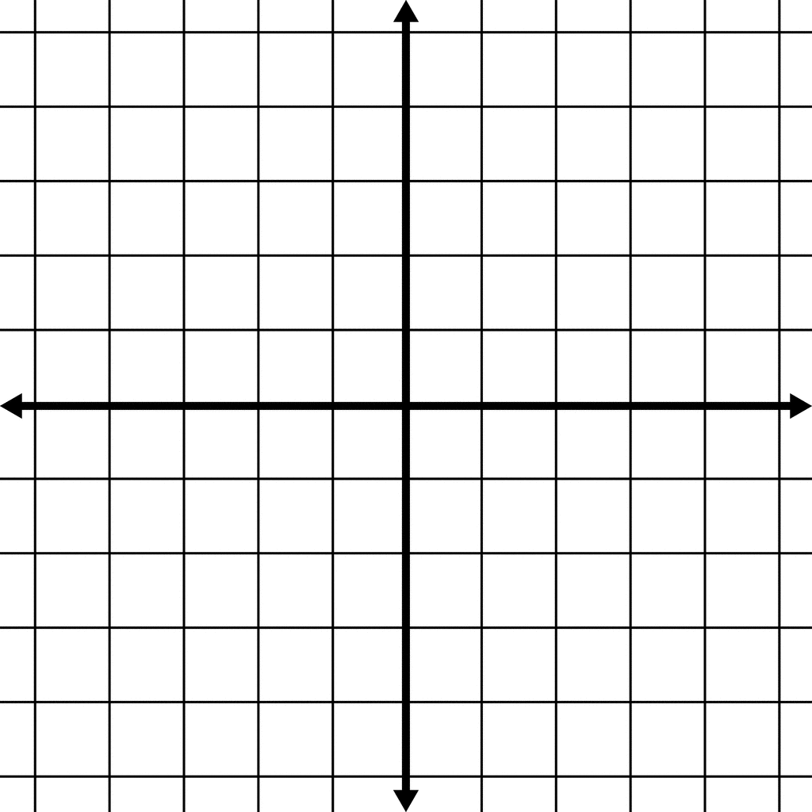
- Find the x-intercepts by factoring.

- Find the y-intercept.

- Graph the function.

5. Solve the following functions without a calculator.

- $2^{x}=8$

- ${\left(\frac{1}{3}\right)}^{x+2}=9$

- ${49}^{x}+1=2{\left(7\right)}^{x}$

